- Python Program to Convert a Decimal Number into Binary, Octal, and Hexadecimal
Program
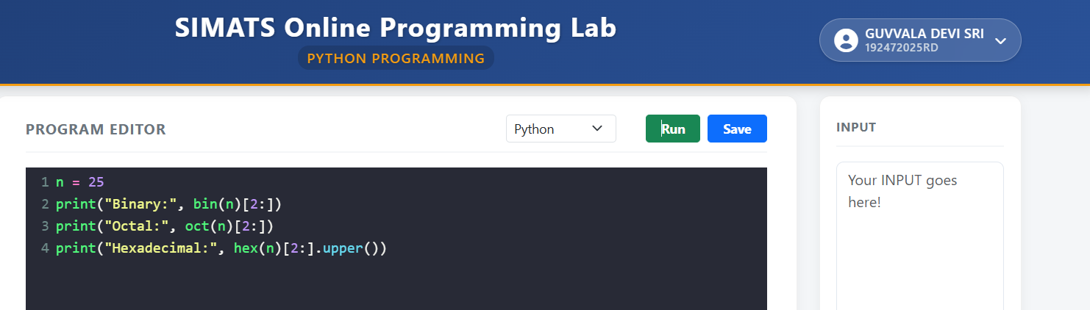

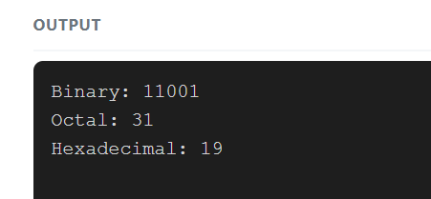

2. Python Program to Convert a Binary, Octal, and Hexadecimal into decimal number

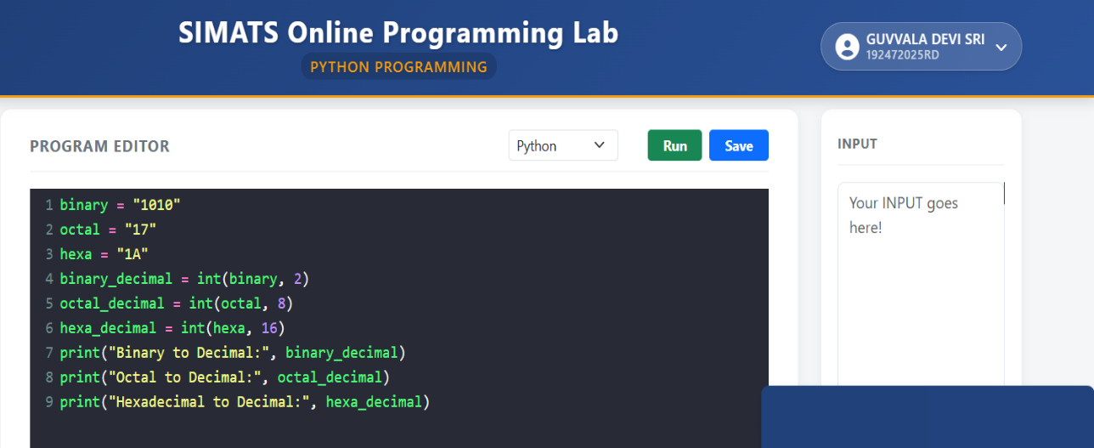
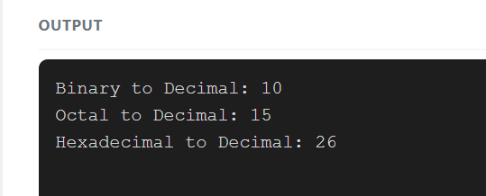

3. Python Program for complex number
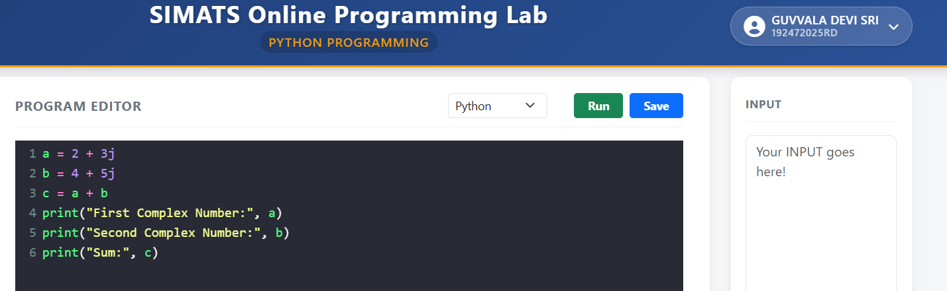

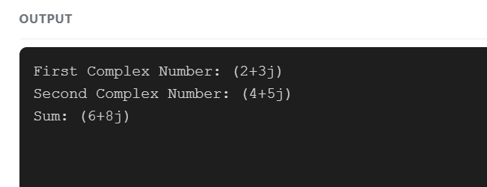

4. Python Program for Division
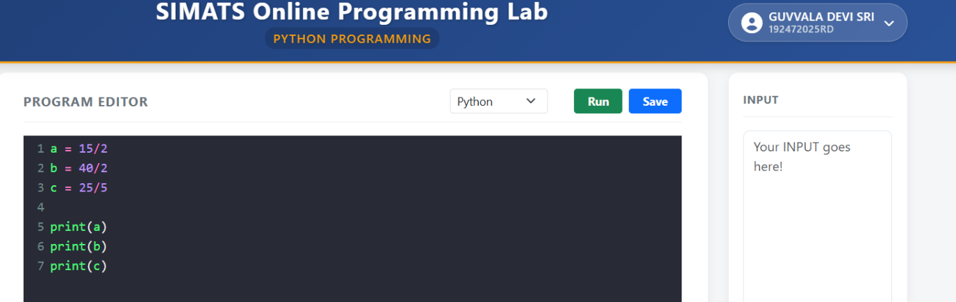
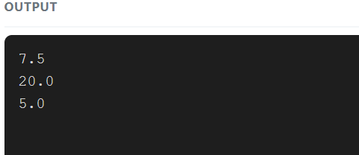

5. Python Program for Floor Division
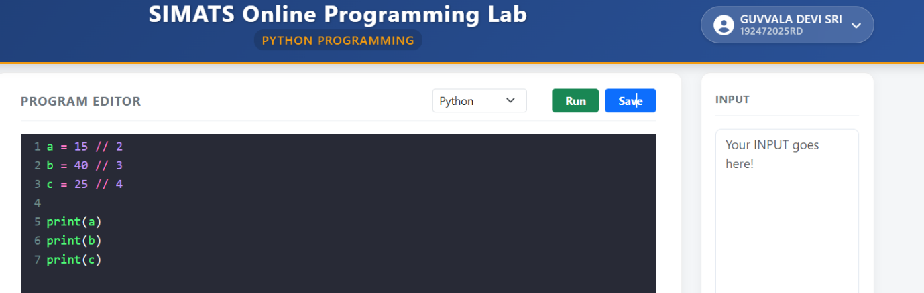
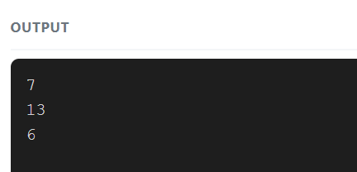
6. Python Program Using the Math Module
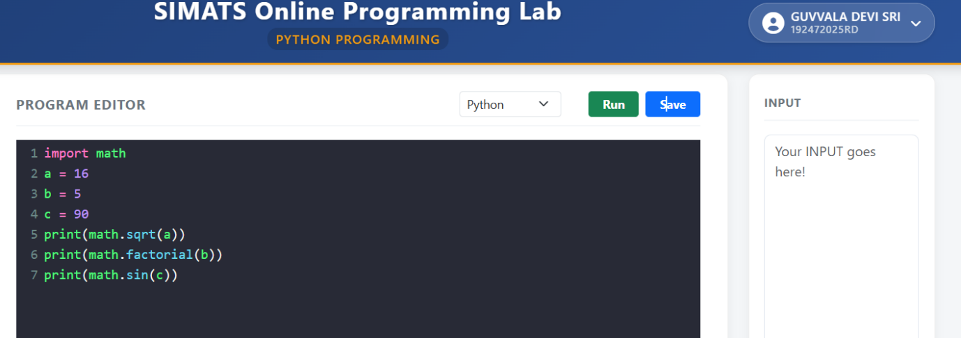
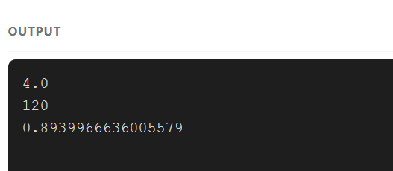

7. Python Program to Convert Days into Months and Days
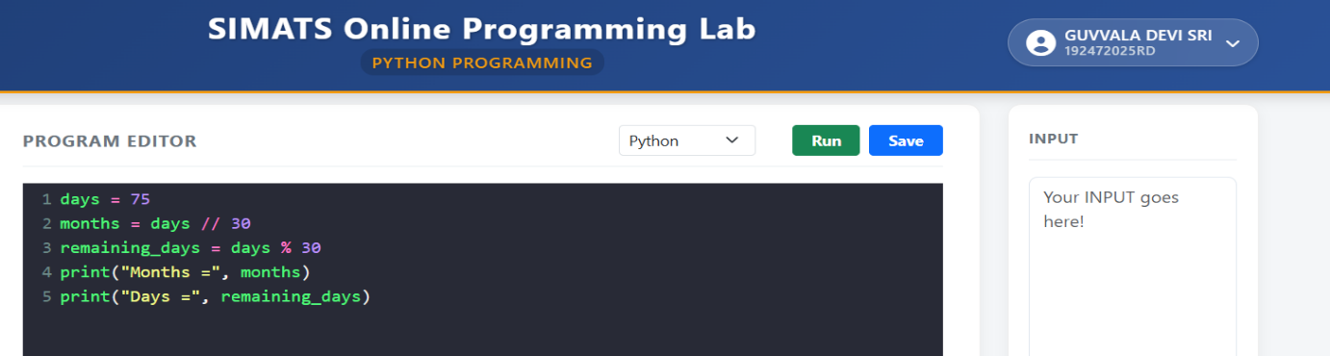

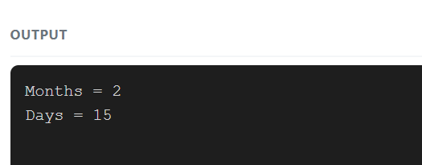
8. Python Program to Find the Average of Three Months
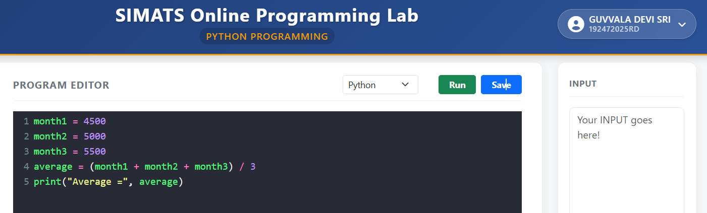
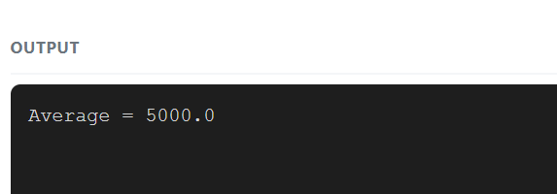

9. Python Program to Interchange Two Numbers
